Result of the Map5_with_barrier_5

Table

Map5_with_barrier
Angle degree | Robot_size | Route distance | Running time (s) | Coverage (%)
357 | 5 | 1983,53 | 68,41 | 75,19
358 | 5 | 2197,19 | 67,25 | 74,02
359 | 5 | 2083,18 | 53,98 | 76,99
0 | 5 | 1888,91 | 98,76 | 67,84
1 | 5 | 2056,63 | 103,6 | 72,85
2 | 5 | 2084,08 | 64,64 | 75,07
3 | 5 | 2031,37 | 72,16 | 70,65
43 | 5 | 2034,42 | 56,69 | 75,82
44 | 5 | 2102,26 | 49,98 | 75,37
45 | 5 | 2051,15 | 48,14 | 76,01
46 | 5 | 2133,34 | 52,74 | 78,17
47 | 5 | 2201,37 | 50,96 | 77,56
48 | 5 | 1891,95 | 64,69 | 76,11
87 | 5 | 2105,14 | 150,09 | 76,91
88 | 5 | 2279,21 | 67,56 | 76,12
89 | 5 | 2025,33 | 77,84 | 73,78
90 | 5 | 2031,43 | 85,37 | 71,94
91 | 5 | 2025,87 | 75,49 | 72,84
92 | 5 | 1991,19 | 83,39 | 73,24
93 | 5 | 2103,74 | 74,39 | 75,07
177 | 5 | 2015,26 | 72,74 | 74,78
178 | 5 | 2216,97 | 172,49 | 75,05
179 | 5 | 2106,7 | 100,06 | 76,82
180 | 5 | 2184,46 | 60,31 | 75,13
181 | 5 | 2187,71 | 60,45 | 73,71
182 | 5 | 2070,19 | 116,72 | 76,42
183 | 5 | 2115,3 | 119,66 | 72,95
223 | 5 | 2002,31 | 57,07 | 75,37
224 | 5 | 2075,95 | 48,88 | 75,9
225 | 5 | 2012,18 | 47,94 | 75,85
226 | 5 | 2053,54 | 52,64 | 78,02
227 | 5 | 2165,01 | 57,3 | 76,5
268 | 5 | 2175,1 | 157,95 | 74,97
269 | 5 | 1980,31 | 105,43 | 74,17
270 | 5 | 2025,72 | 190,29 | 71,38
271 | 5 | 1908,58 | 88,76 | 73,73
272 | 5 | 2270,98 | 80,51 | 72,69
273 | 5 | 2184,53 | 73,49 | 74,36

Blue color is the best result.
Red color is the best Horizontal/Vertical.
Green color is the Best approximate vertical/horizontal angle degrees.

Best result
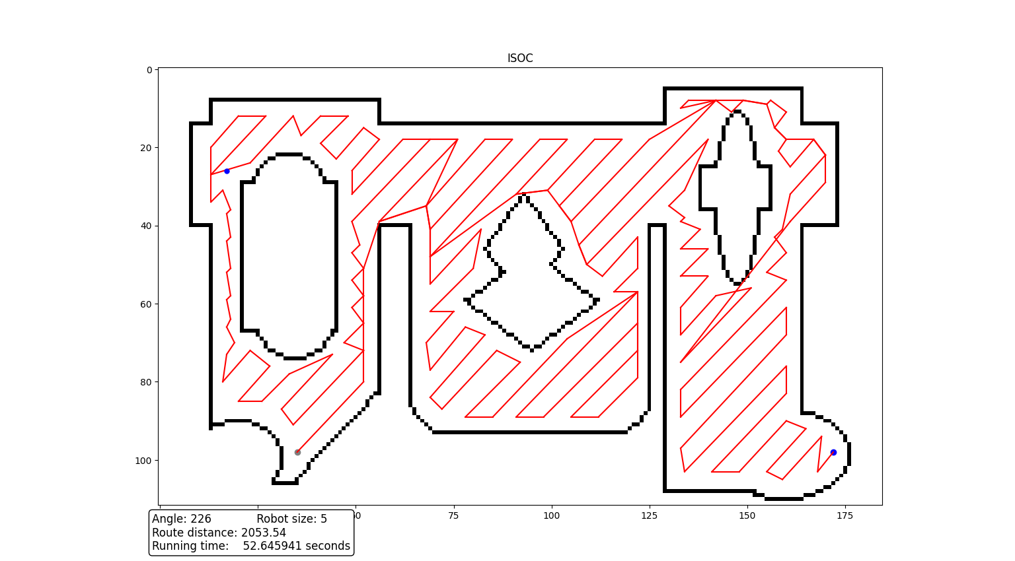
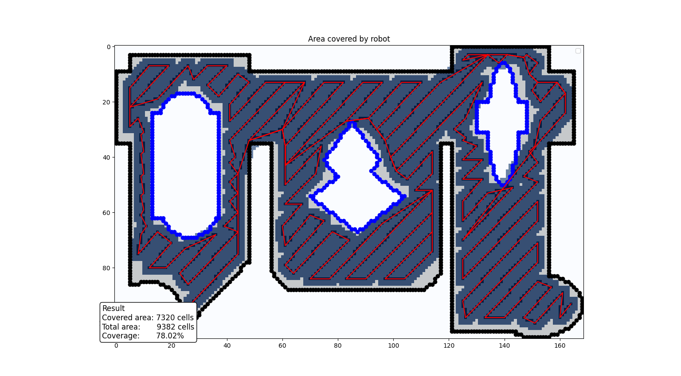


Best horizontal/vertical
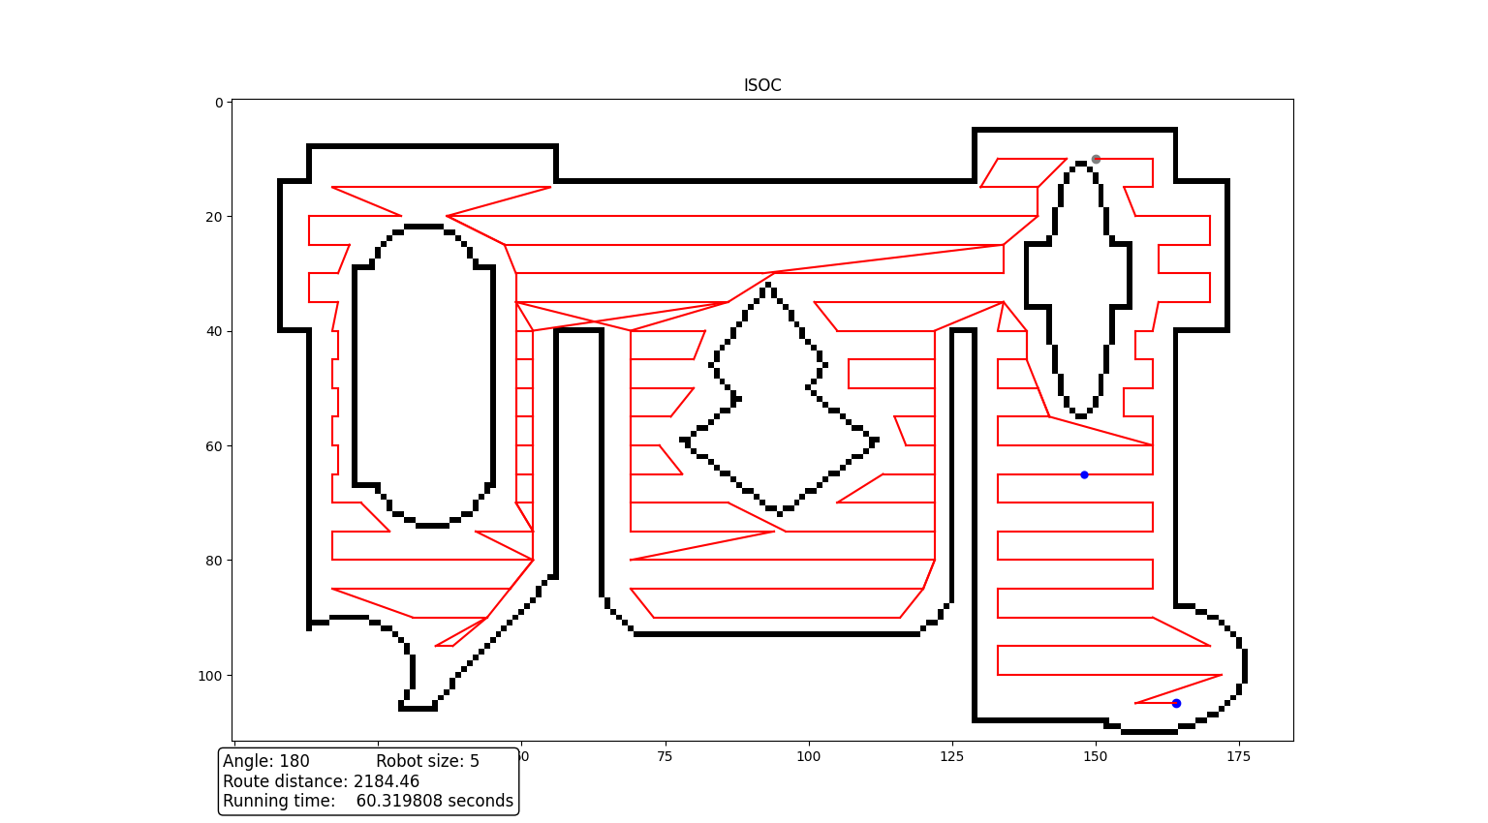
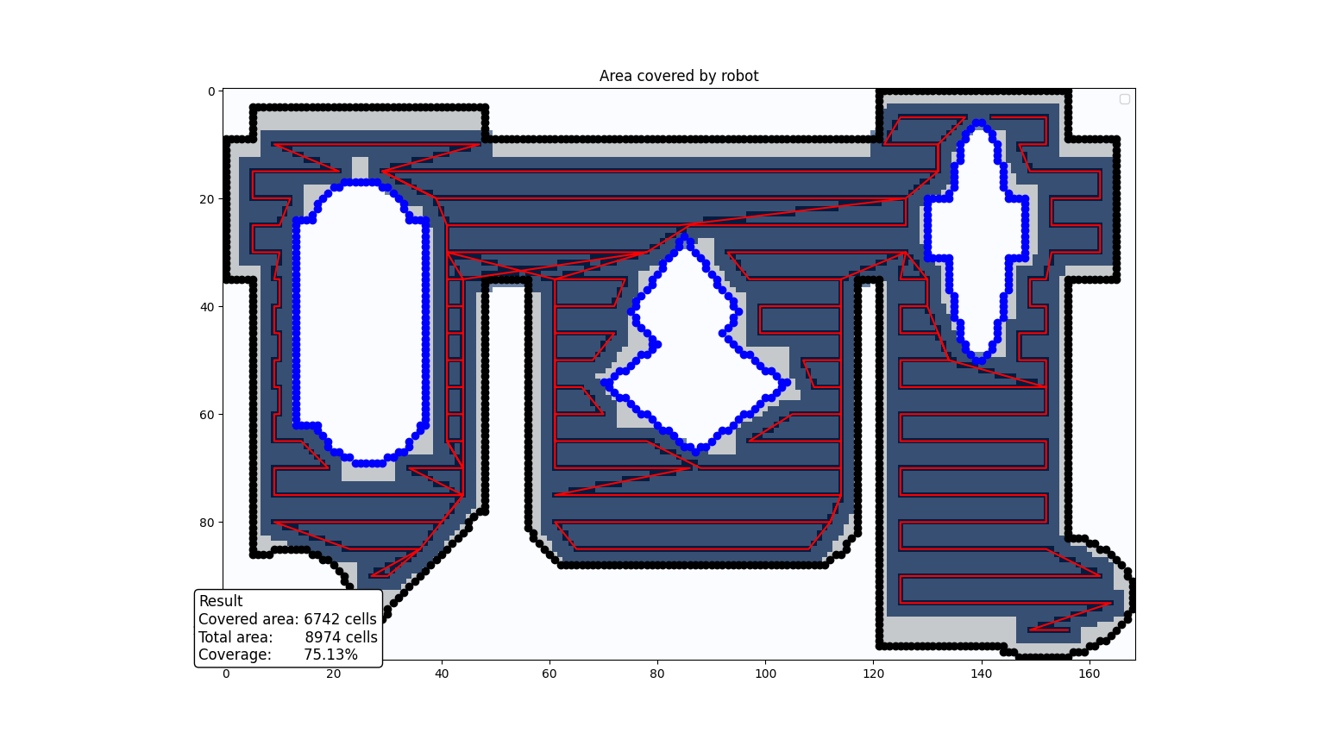

Best approximate vertical/horizontal angle degrees
